Basic Networking Final Exam – 120’
Name :
Correct Answers : / 40
Note: + You can answer either by circle the correct answer(s) or write down your selection at the “Answer: ”
+ Be careful with the multiple choice question. It’s single choice if the question is not mentioned as a multiple choice

QUESTION 01
A host computer has been correctly configured with a static IP address, but the default gateway is incorrectly set. Which layer of the OSI model will be first affected by this configuration error?
A. Layer 1
B. Layer 2
C. Layer 3
D. Layer 4
E. Layer 5
F. Layer 6
G. Layer 7
Answer:

QUESTION 02
In the "host to host" layer of the OSI model, which of the following is a valid connection oriented
protocol?
A. ARP
B. RARP
C. TCP
D. UDP
E. IP
F. ICMP
G. BootP
Answer:

QUESTION 03
The LAN needs are expanding at the GCS office, which is quickly growing. You are instructed to enlarge the area covered by a single LAN segment on the GCS network. Which of the following are layer 2 devices that you can use? (Choose two)
A. A switch.
B. A router.
C. A network adapter card.
D. A hub.
E. A repeater.
F. A Bridge
Answer:

QUESTION 04
Which layer of the OSI reference model is responsible for ensuring reliable end-to-end delivery of data?
A. Application
B. Presentation
C. Session
D. Transport
E. Network
F. Data-Link
Answer:

QUESTION 05
Which OSI layer is associated with the following: The acknowledgement of transmissions,
sequencing, and flow control across a network?
A. Layer 2
B. Layer 3
C. Layer 4
D. Layer 5
E. Layer 6
F. Layer 7
Answer:

QUESTION 06
Which three of the following OSI model layers also belong to the TCP/IP model? (Select three answer choices)
A. The application layer
B. The session layer
C. The data link layer
D. The transport layer
E. The network interface layer
F. The physical layer
Answer:

QUESTION 07
Which three of the protocols below belong to the application layer? (Select three answer choices)
A. ARP
B. HTTPS
C. SMTP
D. CDP
E. TFTP
F. ICMP
Answer:

QUESTION 08
Which of the UTP/STP cable types are used in the A or B or C scenario? (Write three answer below, for example if you think crossover should be used for the scenario X, so you answer: x - 1)

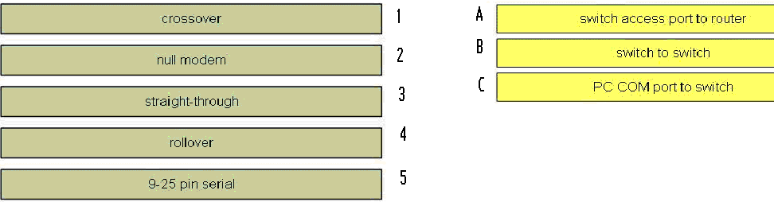
Answer:
A –
B –
C –

QUESTION 09
You have set up an Internet based FTP server, where people can upload and download files. In terms of the OSI model, what is the highest layer used during the FTP sessions.
A. Application
B. Presentation
C. Session
D. Transport
E. Internet
F. Data Link
G. Physical
Answer:

QUESTION 10
You have set up an Internet based FTP server, where people can upload and download files. In terms of the OSI model, what is the highest layer used during the FTP sessions.
A. Application
B. Presentation
C. Session
D. Transport
E. Internet
F. Data Link
G. Physical
Answer:

QUESTION 11

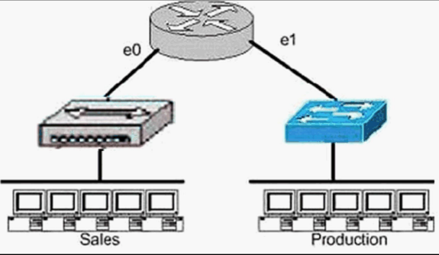
Which of the following statements most accurately describes the characteristics of the above networks broadcast and collision domains? (Select the two answer choices)
A. There are two broadcast domains in the network.
B. There are four broadcast domains in the network.
C. There are six broadcast domains in the network.
D. There are four collision domains in the network.
E. There are five collision domains in the network.
F. There are seven collision domains in the network.
Answer:

QUESTION 12

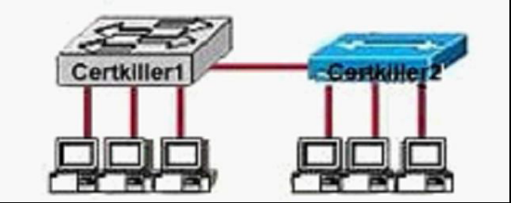

Based on the diagram shown above, which of the devices shown can transmit simultaneously without causing collisions?
A. All hosts
B. Only hosts attached to the switch
C. All hosts attached to the hub and one host attached to the switch
D. All hosts attached to the switch and one host attached to the hub
Answer:

QUESTION 13
The GCS LAN consists of 10 PC users as shown in the diagram below: Each of the hosts is connected to their own 10Mbps half-duplex switch port to the e0 interface of a router. How much bandwidth is available to each individual host?
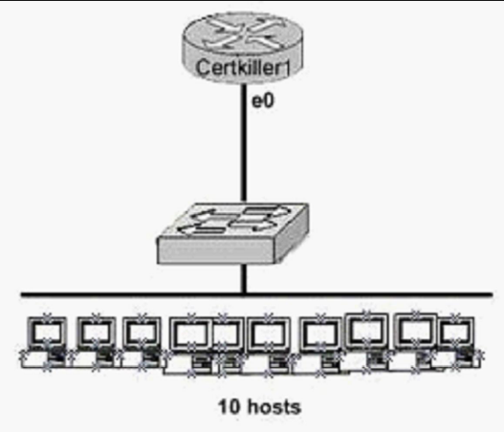
A. 1 Mbps
B. 10 Mbps
C. 20 Mbps
D. 100 Mbps
E. 120 Mbps
Answer:

QUESTION 14
On a half-duplex Ethernet LAN, two hosts attempt to send data simultaneously, resulting in a
collision. Following this collision, what will the hosts do?
A. The destination host sends a request to the source for retransmission.
B. The jam signal indicates that the collision has been cleared.
C. The hosts will attempt to resume transmission after a time delay has expired.
D. An electrical pulse indicates that the collision has cleared.
E. The router on the segment will signal that the collision has cleared.
F. The hosts will do nothing, as the higher layers are responsible for data error correction and retransmission.
Answer:

QUESTION 15
What are the differences between full-duplex Ethernet and half-duplex Ethernet? (Select two)
A. Half-duplex Ethernet operates in a shared collision domain.
B. Full-duplex Ethernet has a lower effective throughput.
C. Half-duplex Ethernet operates in a private collision domain.
D. Full-duplex Ethernet allows two-way communication.
E. Half-duplex Ethernet operates in a private broadcast domain.
Answer:

QUESTION 16
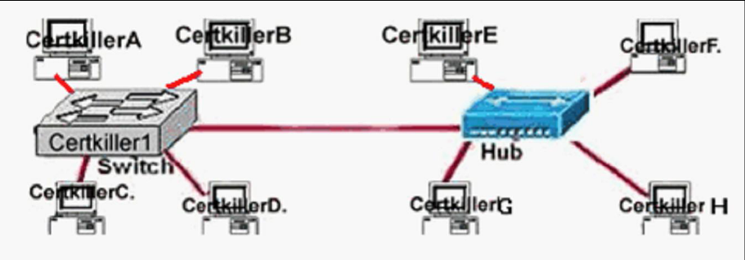
Which statements describe the interconnections displayed in the exhibit? (Select two)
A. Traffic from host CertkillerA to host CertkillerD will be collision free.
B. Traffic from host CertkillerC to host CertkillerG will be collision free.
C. Traffic from host CertkillerE to host Certkiller G will be collision free.
D. Host CertkillerB can be connected at full duplex.
E. Host Certkiller F can be connected at full duplex.
Answer:

QUESTION 17
Which of the protocols below use TCP at the transport layer? (Select four)
A. TFTP
B. SMTP
C. SNMP
D. FTP
E. HTTP
F. HTTPS
Answer:

QUESTION 18
Which of the following protocols utilize UDP as the layer 4 transport mechanism?
(Choose all that apply)
A. TACACS
B. Telnet
C. SMTP
D. SNMP
E. HTTP
F. TFTP
Answer:

QUESTION 19
Which one of the following protocols uses both UDP and TCP ports for the
transport layer operation?
A. FTP
B. TFTP
C. SMTP
D. Telnet
E. DNS
Answer:

QUESTION 20
Which of the following protocols utilize TCP? (Choose all that apply)
A. NTP
B. NNTP
C. SMTP
D. SNMP
E. HTTPS
F. TFTP
Answer:

QUESTION 21
A legacy network that is prone to errors may have issues with services that use UDP.
Which of the following services could have problems in this case, due to the fact that
UDP is used? (Select three answer choices.)
A. DNS
B. Telnet
C. SMTP
D. SNMP
E. HTTP
F. TFTP
Answer:

QUESTION 22
Regarding DHCP (dynamic host configuration protocol), which two of the following
choices below are true? (Select two answer choices)
A. The DHCP Discover message uses FF-FF-FF-FF-FF-FF as the Layer 2 destination address.
B. The DHCP Discover message uses UDP as the transport layer protocol.
C. The DHCP Discover message uses a special Layer 2 multicast address as the
destination address.
D. The DHCP Discover message uses TCP as the transport layer protocol.
E. The DHCP Discover message does not use a Layer 2 destination address.
F. The DHCP Discover message does not require a transport layer protocol.
Answer:

QUESTION 23
The Texas branch network is displayed in the following diagram. The IP address of the E0 interface of the router is 192.168.5.33/27:
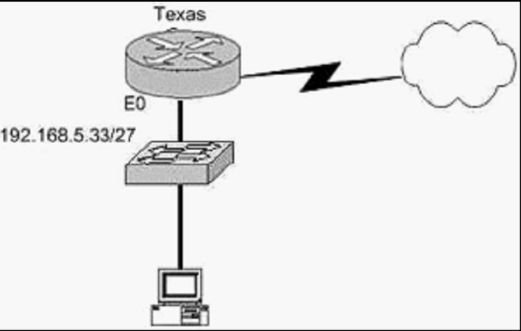
Of the following choices, which IP address should be assigned to the PC host?
A. 192.168.5.10
B. 192.168.5.32
C. 192.168.5.63
D. 192.168.5.40
E. 192.168.5.74
Answer:

QUESTION 24
Which one of the binary number ranges shown below corresponds to the value of the first octet in Class B
address range?
A. 10000000-11101111
B. 11000000-11101111
C. 10000000-10111111
D. 10000000-11111111
E. 11000000-10111111
Answer:

QUESTION 25
How would the number 172 be expressed in binary form?
A. 10010010
B. 10011001
C. 10101100
D. 10101110
Answer:

QUESTION 26
The MAC address for your PC NIC is: C9-3F-32-B4-DC-19. What is the address of the OUI portion of
this NIC card, expressed as a binary number?
Note: The first half of the address identifies the manufacturer of the card. This code, which is
assigned to each manufacturer by the IEEE, is called the organizationally unique identifier
(OUI)
A. 11001100-00111111-00011000
B. 11000110-11000000-00011111
C. 11001110-00011111-01100000
D. 11001001-00111111-00110010
E. 11001100-01111000-00011000
F. 11111000-01100111-00011001
Answer:

QUESTION 27
You have a Class C network, and you need ten subnets. You wish to have as many addresses available for hosts as possible. Which one of the following subnet masks should you use?
A. 255.255.255.192
B. 255.255.255.224
C. 255.255.255.240
D. 255.255.255.248
E. None of the above
Answer:

QUESTION 28
The CISCO network was assigned the Class C network 199.166.131.0 from the ISP. If the
administrator at CISCO were to subnet this class C network using the 255.255.255.224 subnet mask,
how may hosts will they be able to support on each subnet?
A. 14
B. 16
C. 30
D. 32
E. 62
F. 64
Answer:

QUESTION 29
What is the subnet for the host IP address 201.100.5.68/28?
A. 201.100.5.0
B. 201.100.5.32
C. 201.100.5.64
D. 201.100.5.65
E. 201.100.5.31
F. 201.100.5.1
Answer:

QUESTION 30
Which one of the binary bit patterns below denotes a Class B address?
A. 0xxxxxxx
B. 10xxxxxx
C. 110xxxxx
D. 1110xxxx
E. 11110xxx
Answer:

QUESTION 31
Your ISP has assigned you the following IP address and subnet mask:
IP address: 199.141.27.0
Subnet mask: 255.255.255.240
Which of the following addresses can be allocated to hosts on the resulting subnet? (Select three)
A. 199.141.27.2
B. 199.141.27.175
C. 199.141.27.13
D. 199.141.27.11
E. 199.141.27.208
F. 199.141.27.112
Answer:

QUESTION 32
You have a class C network, and you need to design it for 5 usable subnets with each subnet
handling a minimum of 18 hosts each. Which of the following network masks should you use?
A. 225.225.224.0.
B. 225.225.240.0.
C. 225.225.255.0.
D. 255.255.255.224
E. 225.225.255.240
Answer:

QUESTION 33
The network 172.25.0.0 has been divided into eight equal subnets. Which of the following IP
addresses can be assigned to hosts in the third subnet. (Choose three)
A. 172.25.78.243
B. 172.25.98.16
C. 172.25.72.0
D. 172.25.94.255
E. 172.25.96.17
F. 172.25.100.16
Answer:

QUESTION 34
After the router interfaces shown in the diagram have been configured, it is discovered that hosts in
the Branch LAN cannot access the Internet.
Further testing reveals additional connectivity issues.
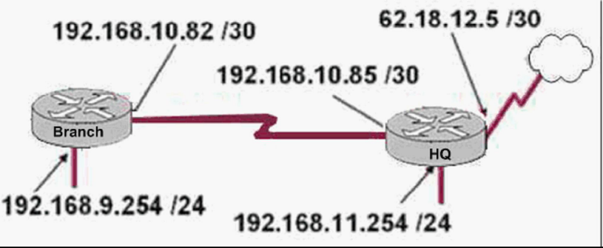
What will fix this problem?
A. Change the address of the Branch router LAN interface.
B. Change the address of the Branch router WAN interface.
C. Change the subnet mask of the HQ router LAN interface.
D. Change the address of the HQ router LAN interface.
E. Change the address of the HQ router interface to the Internet.
F. Change the subnet mask of the HQ router interface to the Internet.
Answer:

QUESTION 35
What command verifies connectivity between two hosts by sending and receiving
ICMP echo messages?
A. ping
B. tracert
C. netstat
D. show cdp neighbors detail
E. show ip route
F. traceroute
Answer:

QUESTION 36
When you use the ping command to send ICMP messages across a network, what's
the most common request/reply pair you'll see? (Select one answer choice)
A. Echo request and Echo reply
B. ICMP hold and ICMP send
C. ICMP request and ICMP reply
D. Echo off and Echo on
E. None of the above
Answer:

QUESTION 37
What kind of message does a PING send out to test connectivity?
A. ICMP echo request
B. Information interrupt request
C. Timestamp reply
D. Source quench
E. None of the above
Answer:

QUESTION 38
What does a Layer 2 switch use to decide where to forward a received frame?
A. source MAC address
B. source IP address
C. source switch port
D. destination IP address
E. destination port address
F. destination MAC address
Answer:

QUESTION 39
Which of the following routing protocol are the interior routing protocol? (select three)
A. RIP v1
B. RIP v2
C. BGP
D. OSPF
Answer:

QUESTION 40
A host computer has been correctly configured with a static IP address, but the
default gateway is incorrectly set. Which layer of the OSI model will be first affected
by this configuration error?
A. Layer 1
B. Layer 2
C. Layer 3
D. Layer 4
E. Layer 5
F. Layer 6
E. Layer 7
Answer:

